**Name: _______________________________________ Partner: ________________________________**

**Python Activity 10: Looping Structures -- Nested Loops**

|  |
| --- |
| **Learning Objectives**  Students will be able to:  *Content:*   * Read and write nested FOR loops * Identify inner and outer loops   *Process:*   * Write code that uses a nested FOR loop   **Prior Knowledge**   * Python concepts from Activities 1-10 |

|  |
| --- |
| **FYI:** A loop within another loop is known as a **nest loop.** Proper indentation is essential for the loops to work properly.. |

1. Enter and execute the following code:

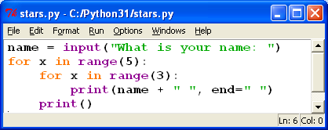

a. What does the program display?

It printed my name 15 times.

b. How many FOR loops are in this code? 2 Is one loop completely executed before the next loop begins? no What do you call this type of loop? Nested loops

c. How many times is the following line of code executed in the program? 15 times



d. Label the **inner loop** and the **outer loop**. Range(5) is outer range (3) is inner

e. What does the **inner loop** do? Prints my name 3 times

f. What does the **outer loop** do? Repeats the inner loop 5 times

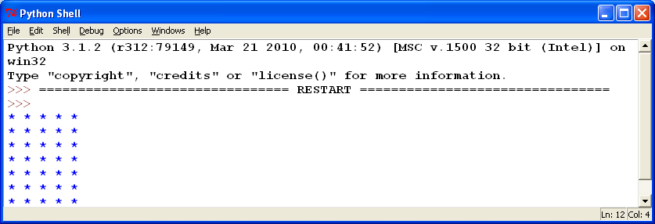2. If you were asked to create a Python program that displayed the adjacent rectangle, you could easily do it with a set of print statements. You can also create it with a FOR loop and a print statement. This exercise will go through the steps to create a program that will print similar output but allows the user to determine the length and width of the figure when they execute the program.

a. Create a code segment that prompts the user for a number between 1 and 10 and then prints that many asterisks (*) on one line. Use a FOR loop. Although you should test the user input to be sure it is in range (between 1 & 10), you do not need to do that here.

coloumns=int(input("Enter a number of coloumns up to 10: "))

for x in range(coloumns):

print("*",end=" ")

b. You want the program to create several lines of asterisks. Extend the code in “a.” to also prompt the user for how many rows to print. Use an “outer” loop to print that many lines of asterisks. Write the revised code below.

rows=int(input("Enter a number of rows up to 10: "))

coloumns=int(input("Enter a number of coloumns up to 10: "))

for x in range(rows):

for x in range(coloumns):

print("*",end=" ")

print()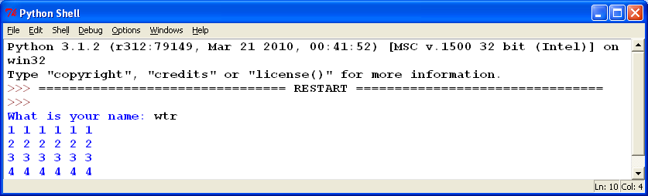

c. Edit the program so that it prints numbers instead of asterisks. Write the line of code that was changed.

rows=int(input("Enter a number of rows up to 10: "))

coloumns=int(input("Enter a number of coloumns up to 10: "))

num=1

for x in range(rows):

for x in range(coloumns):

print(num,end=" ")

num+=1

print()

3. Examine the following code and determine the output. Indicate the changes in memory as the program is executed. Assume the user input is **5.**

|  |  |
| --- | --- |
| **Variable** | **Memory** |
| Height | 5 |
| Row | 1 |
| Column | 5 |

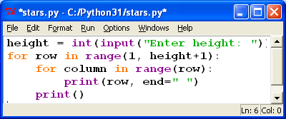

**Application Questions: Use the Python Interpreter to check your work**

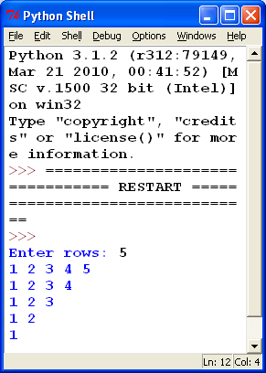

1. Create a *Python* program that prompts the user for a number and then prints an inverted right triangle containing that many rows similar to the output to the right.

row= int(input("Enter rows: "))

for x in range(row):

for y in range(row-x):

print(y+1, end=" ")

print()

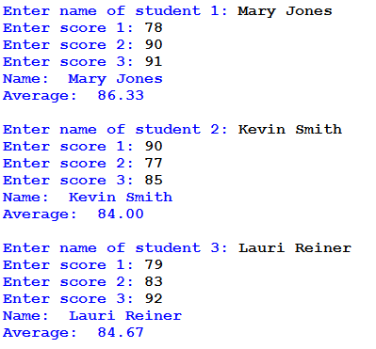

2. Write a program the prompts the user for information for three students. For each student prompt for the student ID and three quiz grades. Use a nested loop, where the inner loop prompts for the three quiz grades. Print the student’s name and average – formatted to two decimal places. View the sample output as a guide.

for x in range(3):

name = input("Enter name of student " + str(x+1) + ": ")

grades=0

for y in range(3):

score=float(input("Enter score " +str(y+1) + ": "))

grades+=score

average= grades/3

print("Name:",name)

print("Average:",format(average, '.2f'))